**Hospital Management Application**

Srinath Penugonda

GitHub: <https://github.com/Srinath2905/Hospital-Management-System.git>

04-04-2022

**Initial Proposal**

During the course I would like to develop a hospital management application. In today’s world corporate hospitals are more in demand, so the application needs to be maintained efficiently. Hospital management database contains data mainly related to Patients, Doctors, Appointments, Billing, Diagnose, Labs, Feedback.

The data stored here is very important. Most of the patients schedule an appointment with the doctor but, there are few patients who are unable to schedule an appointment due to unexpected health conditions and needs a doctor and attendant employees. In such scenario we can make use of database and retrieve which doctor and staff can attend the patient immediately. And also using feedback details from the database, increments and promotions can be allocated to hospital staff.

Few patients will pay the bill directly but few pay through installments and few claim insurance. So, we will be using the live data and also data flowing in from banks, insurance groups, laboratories. All the data should be collected and shown under a single application.

Mostly the data is used by the head group of the organization in the form of reports to analyze whether the hospital is running on the profit end or not. And also, to check where it stands in the competition of corporate hospitals.

**Relational Database Design Process**

As already mentioned in the Initial proposal the below are my main entities and their attributes.

**Entity 1**

|  |  |
| --- | --- |
| **PATIENT** | DATA TYPE |
| PatientID | INT |
| PatientRegdNo | VARCHAR(45) |
| FirstName | VARCHAR(45) |
| LastName | VARCHAR(45) |
| DateOfBirth | DATE |
| Gender | VARCHAR(10) |
| PhoneNumber | VARCHAR(12) |
| EmailID | VARCHAR(45) |
| BloodGroup | VARCHAR(10) |

**Entity 2**

|  |  |
| --- | --- |
| **DOCTOR** | DATATYPE |
| DoctorID | INT |
| DoctorName | VARCHAR(45) |
| EmailID | VARCHAR(45) |
| Specialization | VARCHAR(45) |

**Entity 3**

|  |  |
| --- | --- |
| **APPOINTMENT** | DATATYPE |
| PatientID | INT |
| DoctorID | INT |
| AppoitmentDate | DATETIME |
| AppointmentType | VARCHAR(45) |

**Entity 4**

|  |  |
| --- | --- |
| **BILLING** | DATATYPE |
| PatientBillingID | INT |
| PatientRegisterID | VARCHAR(45) |
| TransactionDesc | VARCHAR(45) |
| Amount | DECIMAL(8,2) |
| GeneratedDate | DATETIME |
| PatientAddress | VARCHAR(100) |
| PaymentType | VARCHAR(45) |

**Entity 5**

|  |  |
| --- | --- |
| **LAB** | DATATYPE |
| PatientLabReportID | INT |
| PatientRegisterID | VARCHAR(45) |
| DiseaseName | VARCHAR(100) |
| LabTestID | INT |
| TestValue | VARCHAR(45) |
| Comment | VARCHAR(100) |

**Data Sources**

I have created three records per each entity using delimited comma separated values. Below mentioned are my five separate files each containing 3 records. I am attaching them in github.

Patient.csv

Doctor.csv

Appointment.csv

Billing.csv

Lab.csv

**ER Diagram**

**UMLet ( HospitalManagement.Uxf)**

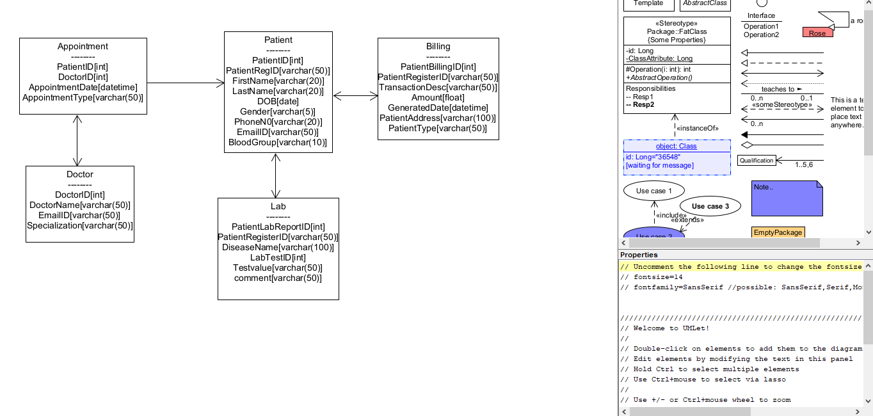

**Vertabelo (Hospital_Management.pdf)**

